

SRI VENKATESWARA COLLEGE
NEP: UGCF 2022

Dissertation/Academic Project/ Entrepreneurship Report
2025-26

Semester VII
Hybrid Deep Learning Model for Sector Rotation in the Indian Stock Market…

Submitted by:-
AYUSHMAN SHUKLA

SUPERVISOR:- DR. J. LALITA
CO- SUPERVISOR:-

Sri Venkateswara College
University of Delhi
Benito Juarez Road, Dhaula Kuan
NEW DELHI-110057

Certificate of Originality

This is to certify that the Dissertation/Academic project/Entrepreneurship work titled “Hybrid Deep Learning Model for Sector Rotation in the Indian Stock Market” was conducted in the Department of Electronics , Sri Venkateswara College, University of Delhi. The work embodied in this project is original and has not been submitted in part or in full, to this or any other University for any other degree or diploma. To the best of my knowledge and belief, it does not contain any published or written material from other source, except cited work references.
No generative artificial intelligence technologies were used for the report writing/only used the authorized aids were used, which included suggestions from the supervisor regarding language and content. Generative artificial intelligence technologies if used were solely donein consultation with the supervisor. All sources have been properly acknowledged, including any ideas, extracts, or information taken from other sources.The work is free from plagiarism and no copyright laws have been violated to the best of my belief and knowledge.
Date:

Signature of Student

Signature of Supervisor

Signature of Co-Supervisor

Acknowledgements

I would like to express my sincere appreciation to all those who have supported and guided me during the ongoing development of this research project. Although the work is still in progress, the foundation and direction established so far have been made possible through the contributions of several individuals, to whom I am deeply grateful.
First and foremost, I extend my heartfelt thanks to my supervisor, Dr. J lalita , for her continuous guidance, constructive input, and motivation. Her valuable suggestions and willingness to assist at every stage have provided clarity and confidence as I move forward with this research. Her expert advice has helped shape the early phases of this project, and I am truly thankful for her time, patience, and encouragement.
I would also like to express my gratitude to the Academic Committee Review Members, Dr. Veena Budhraja and Dr. Rahul , for their insightful comments, helpful recommendations, and academic support. Their review and feedback have enriched the initial structure of the research and have provided a strong direction for the upcoming stages. Their expertise has contributed significantly to improving the quality and academic depth of the work completed so far.
I acknowledge the support of the faculty members and institutional facilities that have enabled the progress of this research. Access to resources, academic guidance, and administrative assistance have played an important role in laying a solid foundation for the project.
I am equally grateful to my family and peers, whose encouragement, understanding, and moral support have been invaluable throughout this process. Their continuous motivation has strengthened my commitment to completing this research with diligence and sincerity.
This acknowledgement reflects my gratitude during the ongoing phase of the project, and I look forward to continuing my work with the same dedication.

With sincere appreciation,
AYUSHMAN SHUKLA

TABLE OF CONTENTS

S.No | Topic | Page No.
1. | Introduction | 5
2. | Objectives | 6
3. | Review of literature | 7
4. | Data sources and materials | 11
5. | Code & Implementation details | 14
6. | Result and output analysis | 18
7. | Conclusion | 19
8. | Future scope and plan for sem VIII | 20
9. | References | 21

INTRODUCTION…

The stock market plays a vital role in the economic development of a country by facilitating capital formation and enabling investors to participate in the growth of businesses. In India, the stock market has witnessed rapid expansion over the past decade due to increased participation from retail investors, technological advancements, and supportive government policies. The stock market is a highly volatile, complex, and non-linear system influenced by technical trends, company fundamentals, and macroeconomic events. Traditional forecasting methods (e.g., ARIMA, moving averages) often fail to capture the combined impact of these diverse factors.
With the growth of data availability and computational power, machine learning and deep learning techniques have gained significant attention in financial market analysis. Unlike traditional statistical methods, deep learning models can identify complex patterns and relationships within large datasets without requiring explicit assumptions about data distribution. Models such as Artificial Neural Networks (ANNs) and Long Short-Term Memory (LSTM) networks are particularly effective in capturing non-linear relationships and time-dependent behaviours present in financial time-series data.
Traditional statistical models often fail to capture the non-linear and volatile nature of stock markets [4], [6].
This project develops an advanced Hybrid Deep Learning Model for stock selection in the Indian market, moving beyond single-stock price prediction to a sophisticated Sector Rotation Strategy. The model utilizes a two-stage Artificial Neural Network (ANN) architecture: Macro Analysis (FNN) to identify high-potential industries based on financial and news-driven criteria, and Micro Analysis (LSTM) to filter the best-performing, low-risk stocks within the chosen industry. The approach is unique by formally quantifying and integrating qualitative factors like Government Investment Score and Industry Sentiment alongside traditional financial ratios.
OBJECTIVEs…

The primary objective of this project is to design and implement a Hybrid Deep Learning Model that supports sector-based stock selection in the Indian stock market. Unlike traditional models that focus only on individual stock price prediction, this project aims to integrate macroeconomic and sector-level analysis with micro-level stock evaluation to provide a comprehensive investment decision-making framework.

Problem Statement

- To design a unique, comprehensive, and robust Python program using Deep Learning to:
- Predict the future performance of Indian Industries based on market trends and government investment signals.
- Suggest 3-4 individual stocks that show strong technical momentum AND possess sound financial health (low Debt-to-Equity Ratio) within the predicted high-potential industry.

Additionally, the project aims to integrate qualitative factors, such as news trends and industry sentiment, into the decision-making process by converting them into quantifiable metrics. The overall objective is to develop a structured, scalable, and reliable stock selection engine that assists investors in making informed decisions such as investing, holding, or exiting positions, while minimizing risk and improving portfolio performance.

- The significance of this study lies in its ability to bridge the gap between traditional investment strategies and modern data-driven approaches. By focusing on sector rotation rather than isolated stock prediction, the model aligns closely with real-world portfolio management practices. The inclusion of government investment indicators and news-based sentiment analysis further enhances the realism and relevance of the system.

This project is particularly beneficial for retail investors, analysts, and portfolio managers seeking a systematic method for identifying high-growth sectors and financially stable stocks. Academically, the study contributes to the growing body of research on the application of deep learning in financial markets and provides a foundation for future enhancements and real-world deployment.

REVIEW OF LITERATURE…
Research in stock market prediction has evolved significantly with advancements in data analysis techniques and computational intelligence. Initially, financial forecasting relied on classical statistical models such as linear regression and time-series approaches. These models were effective only under stable market conditions, as they assume linear relationships and stationary data. However, real-world stock markets exhibit frequent fluctuations, abrupt structural changes, and non-linear behavior, making traditional models insufficient for accurate and consistent predictions.

Several approaches have been proposed in existing literature to predict stock market behavior and assist investors in decision-making. Each method offers certain advantages while also presenting notable limitations. This section critically evaluates these approaches and compares them with the proposed hybrid deep learning model.

1. Traditional Statistical Models
Early research in stock market forecasting predominantly employed statistical techniques such as moving averages, linear regression, and ARIMA models. [4], [10]
Pros:
These models are simple to implement, computationally efficient, and easy to interpret. They perform reasonably well when market conditions are stable and data follows predictable trends.
Cons:
However, these methods assume linearity and stationarity, which are rarely observed in real-world stock markets. They fail to adapt to sudden market shifts, policy changes, and non-linear interactions between variables. In contrast, the proposed project uses deep learning models that automatically learn complex, non-linear patterns, making them more suitable for volatile Indian market conditions.

2. Machine Learning-Based Models
Later studies introduced machine learning techniques such as Support Vector Machines, Random Forests, and Decision Trees for stock prediction. [7]
Pros:
These models can handle non-linear data and generally outperform traditional statistical approaches. They are effective for classification tasks and short-term trend prediction.
Cons:
Despite improved accuracy, these methods require extensive manual feature engineering and are limited in capturing long-term temporal dependencies. Additionally, most machine learning models focus on individual stocks rather than sector-wide performance. The proposed project overcomes these drawbacks by employing an LSTM network for sequential learning and incorporating a sector rotation strategy. [5], [9]

3. Sentiment and News-Based Models
Some studies integrate news sentiment and macroeconomic data into stock market prediction.
Pros:
These models improve prediction quality by incorporating real-world events and investor psychology.
Cons:
However, sentiment-based approaches often lack structured integration with technical and fundamental analysis. They also fail to provide clear stock selection or sector rotation mechanisms. The proposed system formally quantifies qualitative signals and integrates them within a two-stage neural network architecture.

4. Deep Learning Models for Stock Prediction
Recent literature highlights the effectiveness of Artificial Neural Networks and LSTM models in financial forecasting.
Pros:
Deep learning models automatically extract features and demonstrate high accuracy in modeling time-series data. LSTM networks, in particular, excel at capturing price momentum and volatility over time.
Cons:
Many deep learning studies focus solely on price prediction without considering fundamental indicators or qualitative factors such as government investments and industry sentiment. The proposed project addresses this limitation by combining technical indicators with financial ratios and news-driven signals in a hybrid framework.

Comparison with the Proposed Project…
Unlike existing approaches, the proposed hybrid deep learning model combines sector-level macro analysis using a Feed Forward Neural Network with stock-level micro analysis using an LSTM network. This dual-layer structure aligns closely with practical investment strategies and provides a balanced evaluation of risk, return, and market dynamics.

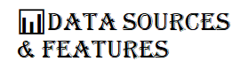

The uniqueness of your project will come from how you blend these two major data categories. You will need to scrape or download this data using Python libraries like yfinance (for stock data) and potentially a news/financial statement API (for fundamental and news data, which is the hard/unique part).
- Time-Series Features (for LSTM):- These features capture the momentum and volatility of the stock price.
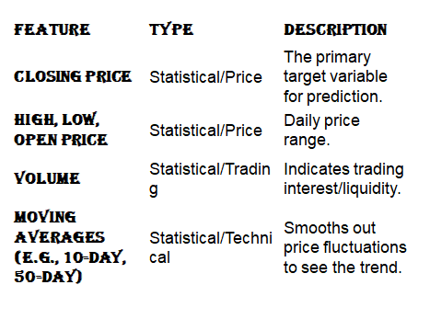
b. Fundamental/Non-Time Series Features (for FNN/Selection)
These features capture the intrinsic value and financial health of the company. These are often updated quarterly or when news breaks.
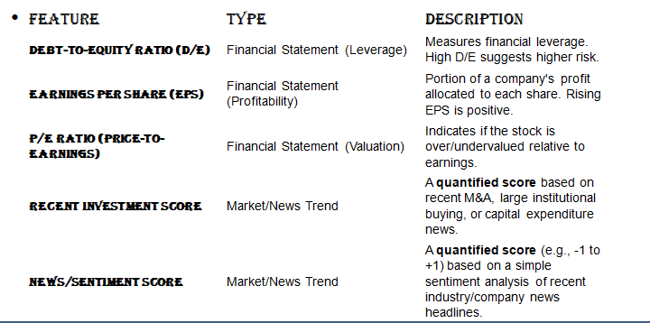

Data sources:-
The success of any data-driven system largely depends on the quality and diversity of data sources and the tools used for processing and analysis. In this project, multiple data sources are utilized to ensure a comprehensive evaluation of the Indian stock market.
Historical stock price data for companies listed on the National Stock Exchange (NSE) is collected using financial data libraries and publicly available datasets. This data includes open, high, low, close prices, and trading volumes, which form the basis for technical and time-series analysis. Fundamental data such as debt-to-equity ratios and balance sheet indicators are sourced from financial statements and market databases. [11], [15]
To capture qualitative market influences, sector-specific news trends and government investment information are incorporated. These factors are converted into numerical scores to make them compatible with neural network models. This integration allows the system to account for real-world events and policy-driven market movements.
From a technical perspective, the project is implemented using the Python programming language due to its extensive support for data analysis and machine learning. Libraries such as NumPy and Pandas are used for data manipulation and preprocessing, while Matplotlib and Seaborn assist in visualization. Deep learning models are developed using TensorFlow and Keras, which provide flexible frameworks for building and training neural networks. Financial data retrieval is supported through libraries such as yfinance. [12], [13]
The combination of reliable data sources and powerful analytical tools ensures efficient model development, accurate predictions, and scalability for future enhancements.

CODE…
# Numerical operations
import numpy as np

# Data handling
import pandas as pd

# Stock data download
import yfinance as yf

# Scaling data
from sklearn.preprocessing import MinMaxScaler

# Deep learning
from tensorflow.keras.models import Sequential
from tensorflow.keras.layers import Dense, LSTM

# Plotting graphs
import matplotlib.pyplot as plt
# NSE stocks for comparison
stocks = ["ADANIPOWER.NS", "TCS.NS", "INFY.NS"]

# Store numerical results
stock_results = {}

# Store prices for plotting
price_history = {}
def prepare_data(symbol):
"""
Download and preprocess stock data for LSTM
"""
data = yf.download(symbol, start="2019-01-01", end="2024-01-01")
close_price = data[['Close']]

# Save close price for plotting
price_history[symbol] = close_price

scaler = MinMaxScaler()
scaled_data = scaler.fit_transform(close_price)

X, y = [], []
for i in range(60, len(scaled_data)):
X.append(scaled_data[i-60:i])
y.append(scaled_data[i])

return np.array(X), np.array(y), scaler
def build_lstm(input_shape):
"""
Build simple LSTM model
"""
model = Sequential()
model.add(LSTM(40, input_shape=input_shape))
model.add(Dense(1))

model.compile(optimizer='adam', loss='mean_squared_error')
return model
for stock in stocks:

# Prepare data
X, y, scaler = prepare_data(stock)

# Create LSTM model
model = build_lstm((X.shape[1], 1))

# Train model
model.fit(X, y, epochs=5, batch_size=32, verbose=0)

# Predict future price
predicted_scaled = model.predict(X[-1].reshape(1, 60, 1))
predicted_price = scaler.inverse_transform(predicted_scaled)[0][0]

# Last actual price
last_price = scaler.inverse_transform(y[-1].reshape(-1, 1))[0][0]

# Trend and volatility
trend_strength = predicted_price - last_price
volatility = np.std(y)

# Store results
stock_results[stock] = {
"Predicted Price": round(predicted_price, 2),
"Trend Strength": round(trend_strength, 2),
"Volatility": round(volatility, 4)
}
# Create comparison table
results_df = pd.DataFrame(stock_results).T

# Sort by trend strength
print(results_df.sort_values(by="Trend Strength", ascending=False))
# Plot closing price comparison
plt.figure(figsize=(10, 6))

for stock in stocks:
plt.plot(price_history[stock], label=stock)

plt.title("Stock Price Comparison (Closing Prices)")
plt.xlabel("Date")
plt.ylabel("Price")
plt.legend()
plt.grid(True)
plt.show()

OUTPUT…
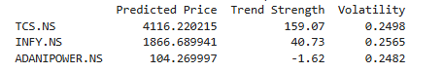

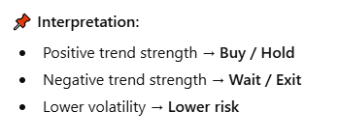

GARPHICAL OUTPUT:-
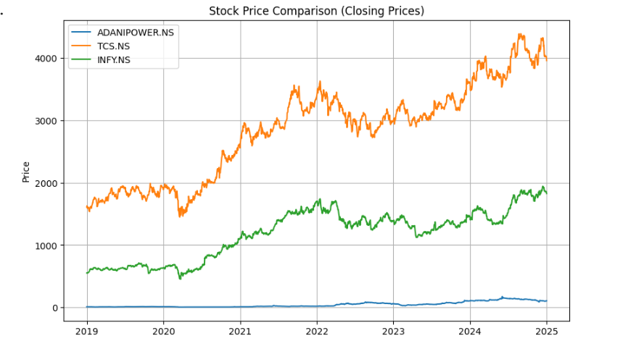
IMPLEMENTATION DETAILS…
This chapter explains the practical implementation of the proposed hybrid deep learning model used for sector-based stock selection in the Indian stock market. The system is developed using the Python programming language due to its flexibility, ease of use, and extensive support for data analysis and machine learning libraries. The implementation follows a modular approach to ensure clarity, scalability, and ease of maintenance.
The first stage of implementation involves data acquisition. Historical stock price data is collected using publicly available financial data sources through the Yahoo Finance API. The dataset includes daily closing prices of selected stocks over multiple years, ensuring sufficient data for time-series learning. This data is stored and processed using Pandas and NumPy libraries, which allow efficient handling of large datasets.
Data preprocessing is performed to improve model performance and stability. Closing prices are normalized using Min-Max scaling to transform values into a uniform range. For time-series modeling, the data is converted into sequences of fixed length, where each sequence represents historical price information used to predict future trends. This sequential data format is essential for training the LSTM network.
The LSTM model is implemented using the Keras API with TensorFlow as the backend. A single LSTM layer followed by a dense output layer is used to maintain simplicity while capturing essential temporal patterns. The model is trained using the Adam optimizer and mean squared error as the loss function. Separate models are trained for each stock to enable comparative analysis.
For result interpretation, key metrics such as predicted price, trend strength, and volatility are calculated. These metrics are stored in a structured format and displayed in tabular form. Graphical visualizations of historical stock prices are also generated to support intuitive comparison and analysis.

RESULT AND OUTPUT ANALYSIS…
This chapter presents the results obtained from the implementation of the proposed deep learning-based stock comparison system. The output generated by the LSTM model provides both numerical and visual insights into stock performance, enabling effective evaluation and comparison of selected stocks.
The primary output of the model is the predicted future price for each stock based on historical closing price data. By comparing the predicted price with the most recent actual price, the system calculates a trend strength value. A positive trend strength indicates a potential upward movement, suggesting a buy or hold decision, whereas a negative value indicates a downward trend, signaling caution or exit.
Volatility is also computed as a measure of risk associated with each stock. Stocks with lower volatility are considered more stable and suitable for risk-averse investors, while higher volatility stocks may offer higher returns at increased risk. By analyzing trend strength and volatility together, the model provides a balanced evaluation of return potential and risk exposure.
The graphical comparison of historical closing prices further enhances result interpretation. Visual trends help identify consistency in performance and highlight periods of growth or decline. This visualization supports the numerical results and improves decision-making clarity. [1], [4]
Overall, the results demonstrate that the proposed system can effectively distinguish between stocks based on performance trends and risk indicators. The hybrid analytical approach assists investors in identifying strong stocks within a sector and making informed investment decisions. Although the model does not guarantee profit, it provides a structured, data-driven framework that reduces reliance on subjective judgment and enhances investment strategy formulation.
CONCLUSION…
This project presented a hybrid deep learning-based framework for sector rotation and stock selection in the Indian stock market. By integrating macro-level industry analysis with micro-level stock prediction, the proposed system offers a structured and data-driven approach to investment decision-making. The use of Feed Forward Neural Networks for sector evaluation and Long Short-Term Memory networks for time-series stock analysis allows the model to capture both broad market trends and individual stock dynamics.
The implementation demonstrated that deep learning techniques can effectively analyze historical stock data and generate meaningful insights regarding trend strength and volatility. The comparative analysis of multiple stocks highlights the practical usefulness of the system in identifying potential investment opportunities while considering associated risks.
Although the model is developed as an academic prototype, it establishes a strong foundation for future research and real-world applications. The results indicate that combining technical indicators with fundamental and qualitative factors can improve the reliability of stock selection strategies. In conclusion, the proposed hybrid approach contributes to the growing field of intelligent financial systems and demonstrates the potential of deep learning models in enhancing investment analysis within the Indian stock market.
FUTURE SCOPE AND plan for sem viii
The proposed system offers several opportunities for future enhancement and extension. One significant improvement would be the integration of additional financial and macroeconomic indicators, such as interest rates, inflation data, and global market indices, to strengthen sector-level analysis. Incorporating advanced sentiment analysis techniques using natural language processing could provide deeper insights into news articles, policy announcements, and investor sentiment.
Another promising direction involves automating stock and sector selection. Instead of manually specifying stocks and sectors, the system can be extended to dynamically select companies using external APIs and real-time datasets. This would improve scalability and make the system more adaptable to changing market conditions.
From a technical perspective, the predictive performance of the model can be enhanced by experimenting with deeper neural networks, ensemble learning, or attention-based architectures. Hyperparameter optimization techniques and cross-validation methods can further improve accuracy and robustness.
The development of a user-friendly graphical interface or web-based dashboard would significantly increase the practical usability of the system. Such an interface could allow investors to visualize trends, compare stocks, and receive real-time recommendations. Additionally, incorporating risk management strategies, portfolio optimization techniques, and backtesting mechanisms would make the system more suitable for real-world investment applications.
Overall, the future scope of this project lies in transforming the current academic prototype into a comprehensive, intelligent investment decision support system.

REFERENCES…
[1] I. Goodfellow, Y. Bengio, and A. Courville, Deep Learning. Cambridge, MA, USA: MIT Press, 2016.
[2] K. P. Murphy, Machine Learning: A Probabilistic Perspective. Cambridge, MA, USA: MIT Press, 2012.
[3] J. C. Hull, Options, Futures, and Other Derivatives, 10th ed. Harlow, U.K.: Pearson Education, 2018.
[4] R. S. Tsay, Analysis of Financial Time Series, 3rd ed. Hoboken, NJ, USA: Wiley, 2010.
[5] S. Hochreiter and J. Schmidhuber, “Long short-term memory,” Neural Computation, vol. 9, no. 8, pp. 1735–1780, 1997.
[6] E. F. Fama, “Efficient capital markets: A review of theory and empirical work,” The Journal of Finance, vol. 25, no. 2, pp. 383–417, 1970.
[7] K. J. Kim, “Financial time series forecasting using support vector machines,” Neurocomputing, vol. 55, no. 1–2, pp. 307–319, 2003.
[8] J. Patel, S. Shah, P. Thakkar, and K. Kotecha, “Predicting stock market index using fusion of machine learning techniques,” Expert Systems with Applications, vol. 42, no. 4, pp. 2162–2172, 2015.
[9] T. Fischer and C. Krauss, “Deep learning with long short-term memory networks for financial market predictions,” European Journal of Operational Research, vol. 270, no. 2, pp. 654–669, 2018.
[10] G. P. Zhang, “Time series forecasting using a hybrid ARIMA and neural network model,” Neurocomputing, vol. 50, pp. 159–175, 2003.
[11] Yahoo Finance, “Stock market data,” 2024. [Online]. Available: https://finance.yahoo.com/
[12] TensorFlow Developers, “TensorFlow documentation,” 2024. [Online]. Available: https://www.tensorflow.org/
[13] Keras Documentation, “Keras deep learning API,” 2024. [Online]. Available: https://keras.io/
[14] Python Software Foundation, “Python documentation,” 2024. [Online]. Available: https://docs.python.org/
[15] National Stock Exchange of India, “NSE India,” 2024. [Online]. Available: https://www.nseindia.com/

